**WEEK 04**

References: (it is not possible to remember everything so please do refer to all the documentations.)

* [https://seaborn.pydata.org/index.html#](https://seaborn.pydata.org/index.html)
* <https://matplotlib.org/3.5.3/api/_as_gen/matplotlib.pyplot.html>
* <https://pandas.pydata.org/docs/index.html>

LIVE SESSION NOTES

1. Whenever we start to work on any dataset the first only step is data preprocessing.
2. Seaborn is a library which we use for data visualisation

MATPLOTLIB RESOURCES

1. Plotting Graphs via Matplotlib 1



pyplot is a component of matplotlib

How to plot a graph:

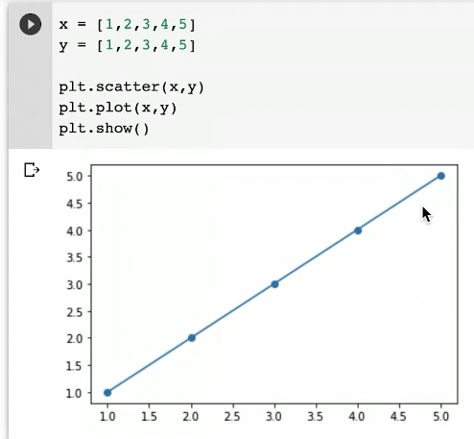

show() function is used to display the graph.

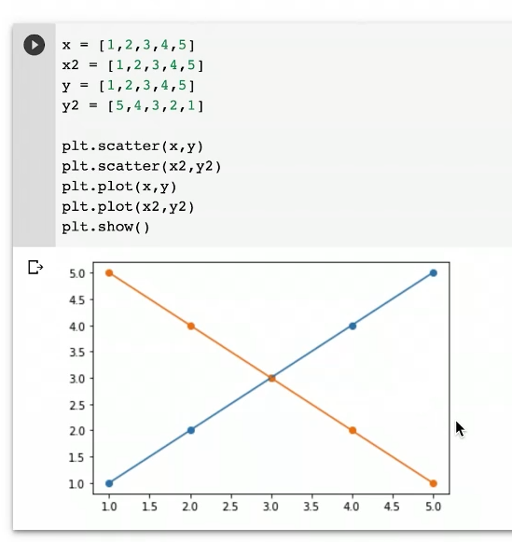

Now if we want to change the color or we want the graph to be different with the same above graph then:

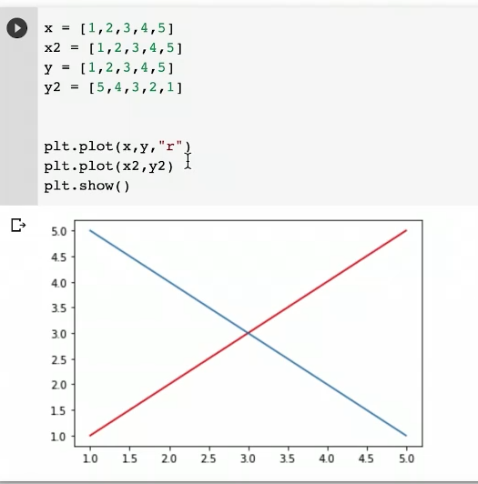

r = defined red color

Here we didn’t got the dots bc we have not used plt.scatter method here (as scatter gives us dots).

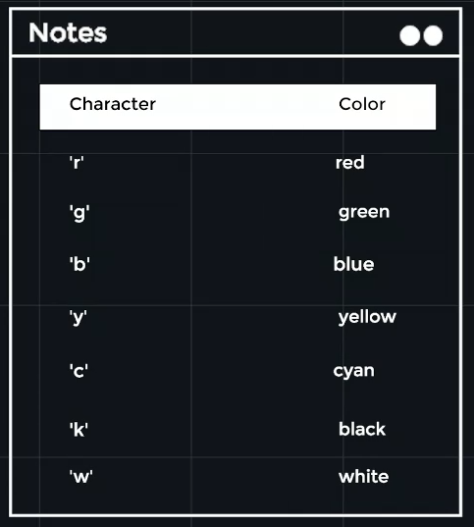

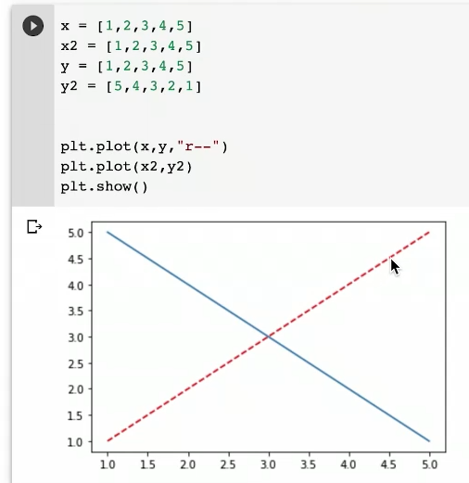

r-- = gives dash line graph.

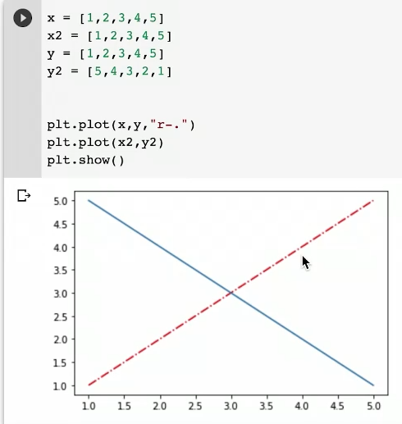

r-. = gives dash dotted graph.

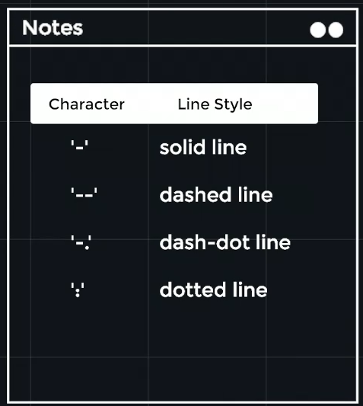

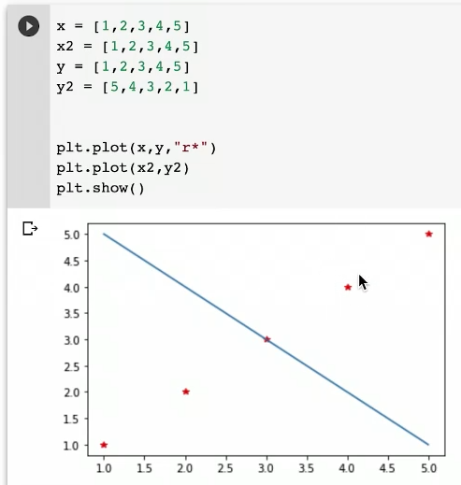

r* = gives * sign graph.

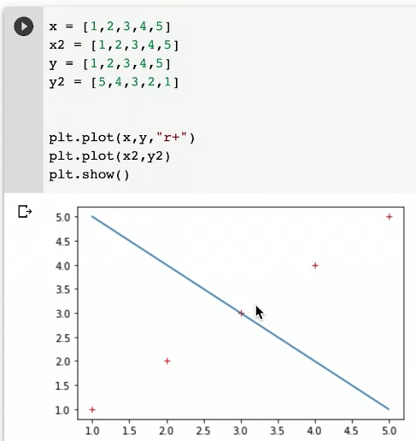

r+ = gives + sign graph.

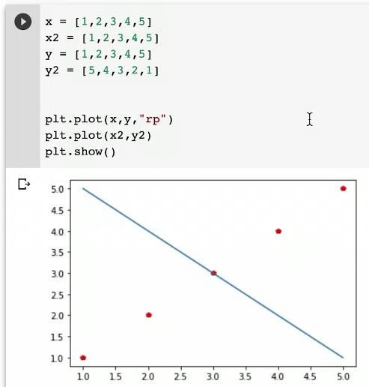

Here p in rp is pentagon.

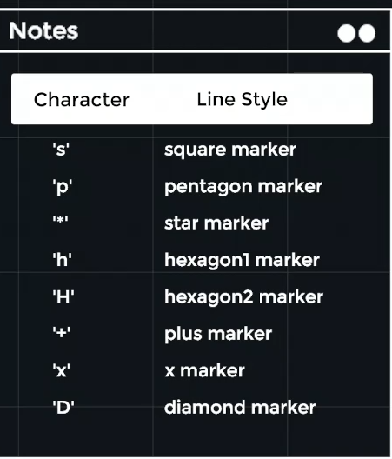

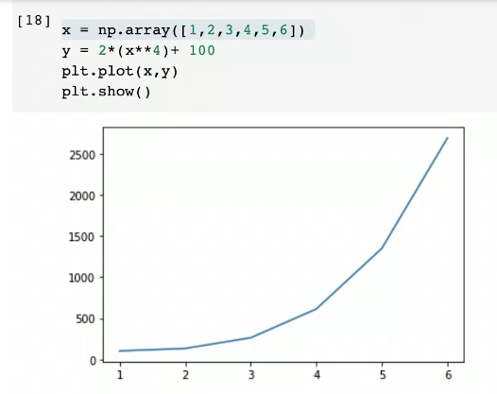

So we can see as this graph is not smooth as we cannot see the plotted points in a clean curvy line so for this we’ll use the arange() function:

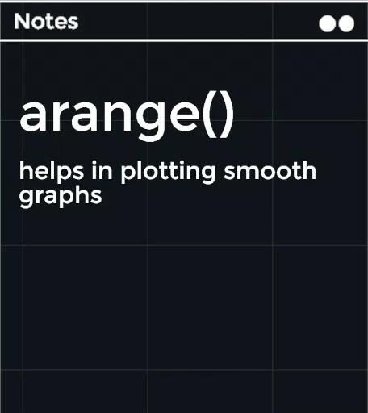

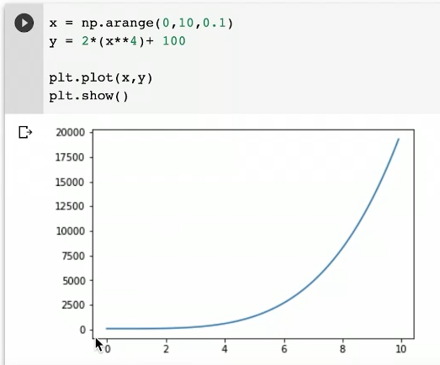

This is the same graph plotted using arange() function where we got a smooth curvy graph.

2. Plotting Graphs via Matplotlib 2

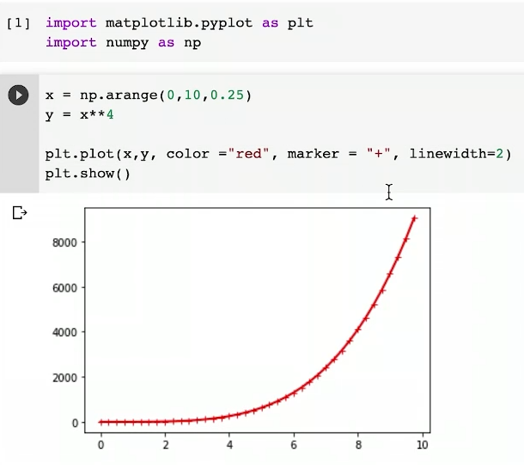

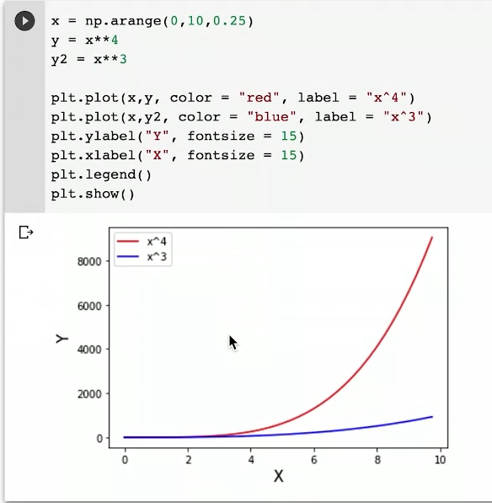

legend() function is used to show the labels.

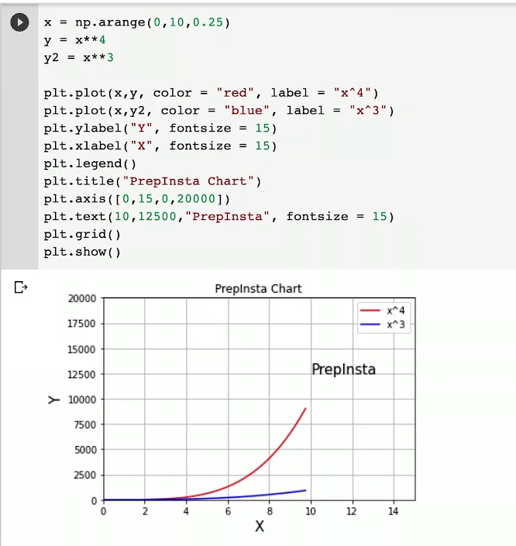

0,15 = x-axis

0,20000 = y-axis

3. Plotting Graphs via Matplotlib 3

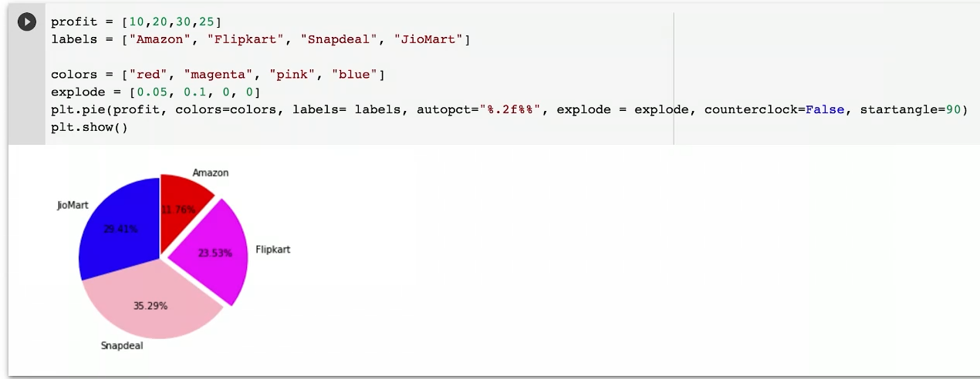

Note: the formation of a pie chart is counter clockwise (it is default if we want, we can change it and make it in opposite direction.)

Here, colors = colors mean the L.H.S ‘colors’ is the default method name and the R.H.S ‘colors’ is the list name that we have create. (same applies to labels = labels)

Remember: The pie chart always starts at the 3 o’clock angle.